**R.V UNIVERSITY.**

**.SCHOOL OF COMPUTER SCIENCE AND ENGG.**

**.B.TECH HONS.**

**Interactive website for sightseeing and exploration page**

**Team members:**

* Thejas Math (1RUA24CSE0503)
* Thushar Chandra(1RUA24CSE0506)

DEPARTMENT OF SOCSE-RV UNIVERSITY.

**Page abstract**

A website that helps users discover nearby sightseeing spots and encourages city exploration. We have built a website that by leveraging their current location to identify attractions and points of interest. The goal is to create an engaging, easy-to-navigate page where users

can quickly find location details and information, all in a streamlined, user-friendly design.

The site includes a main landing page with eye-catching visuals where we can adjust the display setting according to out convenience. Users can explore additional hotspots next to said location with the help of the website.

**Contents**

Introduction---------------------------4

Html code-------------------------------5

Output of static web page------------15

**Introduction**

**Web page code**

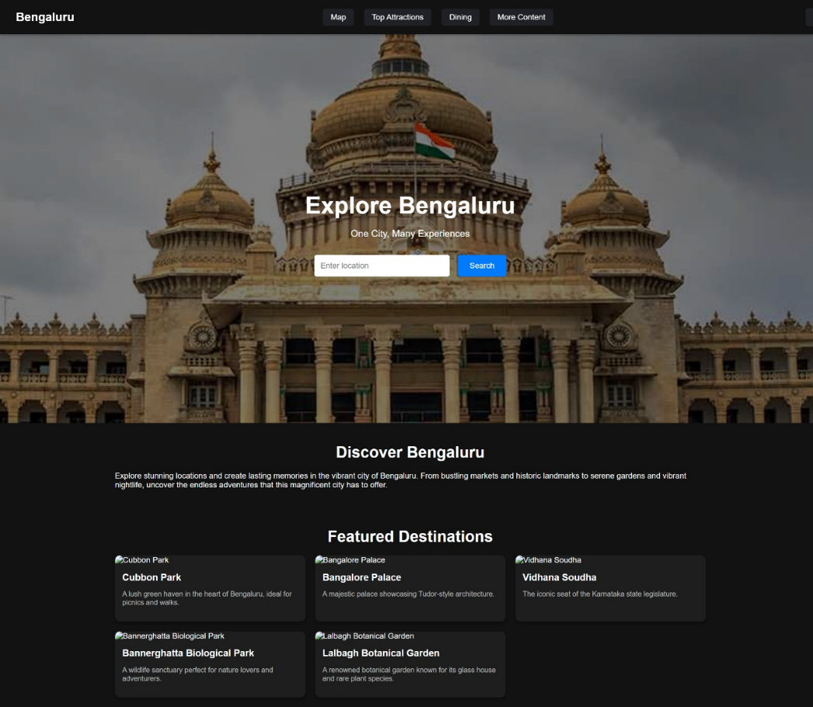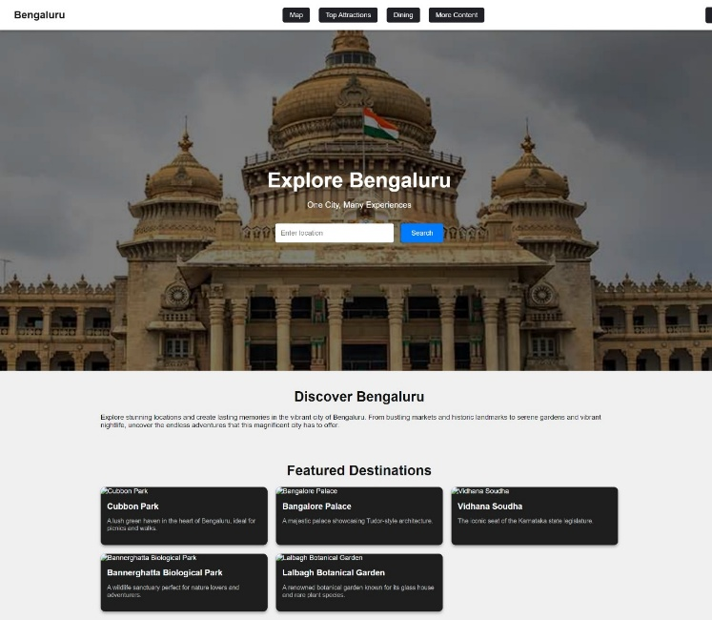**Output:**

